CMPS 183

* **Heading**: Sprint 2 Plan, Draw A Piece, and Completion date: 13 February 2016.
* **Goal:** Having a function interface that lets us manage and control projects.
* **Task Listing:**

1. As a user I would like a “start a project page” instead of a simple canvas, so that I can personalize my projects.

* Create a project creation page. (1 hour)
* Make sure each project has properly divided “pixels”. (2 hours)
* Make sure each project can be set as public/private and other authentication processes.(2 hours)
* Make sure users can rearrange each individual pixel boxes by dragging and dropping. (2 hours)
* Save each project to database so that user can resume where they last left.(3 hours)
* Total time for user story: 9 hours

1. As a user I would like a richer canvas experience, so that I can use more than just basic pencil and eraser.

* Provide the ability to use uploaded pictures as background. (1 hour)
* Fully functional brush size controller and color picker. (1 hour)
* Make sure that the uploaded pictures used as background is set to the database so the data is not lost when exiting (1 hour).
* If the uploaded image is bigger than the canvas size the user should be allowed to crop out as needed (2 hours).
* Total time for user story: 5 hours
* Team Roles:

1. Raman Nakarmi: Scrum Master, Programmer
2. Daniel Ingersoll: Product Owner, Developer
3. Raul Moncayo: Database programmer
4. Anthony Assi: Programmer
5. Daniel Kimmelmann: Programmer

* Initial Task Assignment:
* Raman Nakarmi: User Story 2 (Task 1 and 2)
* Daniel Ingersoll: User Story 1 (Task 1, 2 ), User Story (Task 3)
* Raul Moncayo: User Story 1 (Task 3)
* Anthony Assi: User Story 2 (Task 5)
* Daniel Kimmelmann: User Story 2(Task 4)
* Initial Scrum board: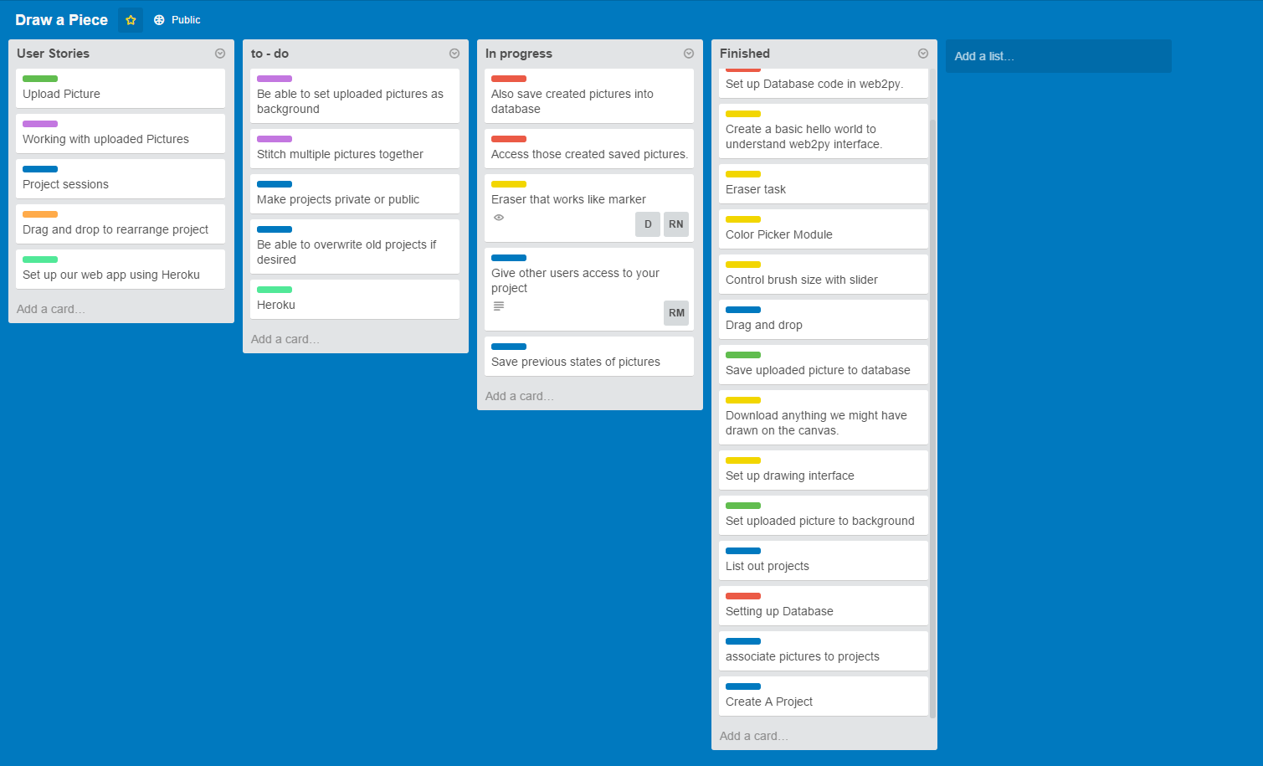
* Scrum Times:
* Monday, Wednesday, Friday: 11:30am